

Mohammad Ali Jinnah University

Chartered by Government of Sindh - Recognized by HEC

**Quiz 1**

**Name:** Muhamad Fahad

**Id:** FA19-BSSE-0014

**Subject:** [Linear Algebra (Fall 2020)](https://classroom.google.com/u/0/c/MTgxNTU3ODEwMjQw)

**Section:** AM

**Teacher:** Dr. Asmat Ara

**Date:** Monday, November 2, 2020

# 

Q.1 Solve the following system by Gaussian Jordan method.

$x+y+ 2z =9$

$$2x+4y-3z =1$$

$3x+6y-5z =0$

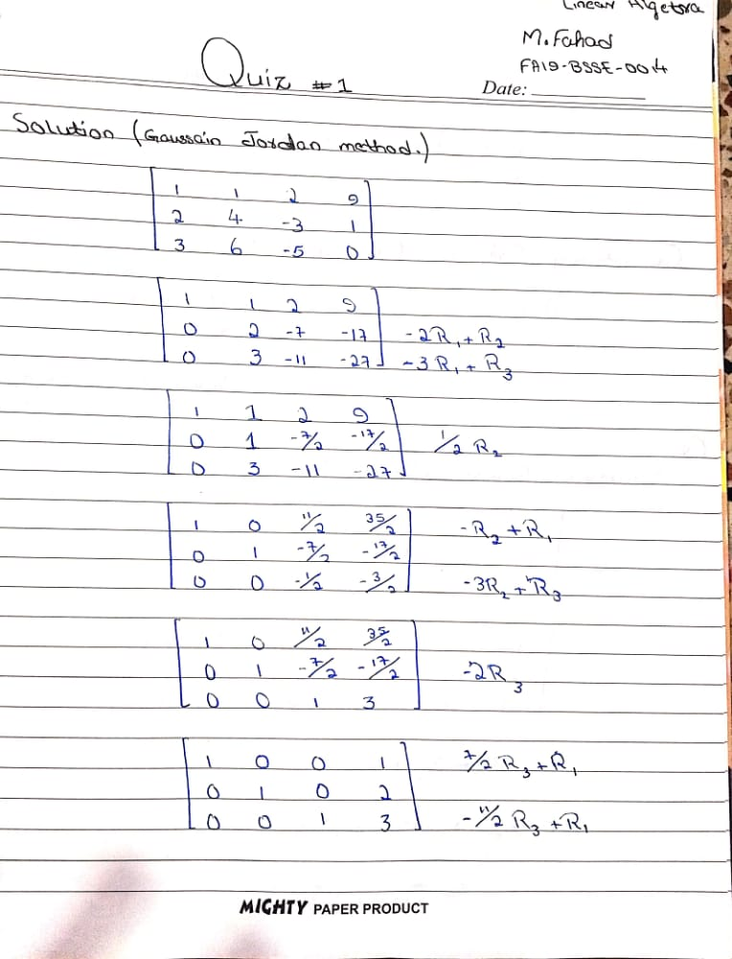

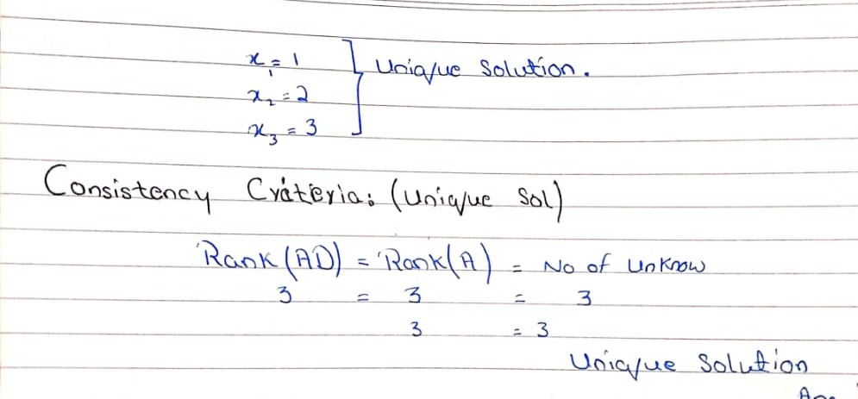

Q.2 Solve the following system by Gaussian Elimination method.

$x-y+ 2z =5$

$$2x-2y+4z =10$$

$3x-3y+6z =15$

